PROFILE

1 | Name: |  |  | Pralayakaveri Raju |  |  | 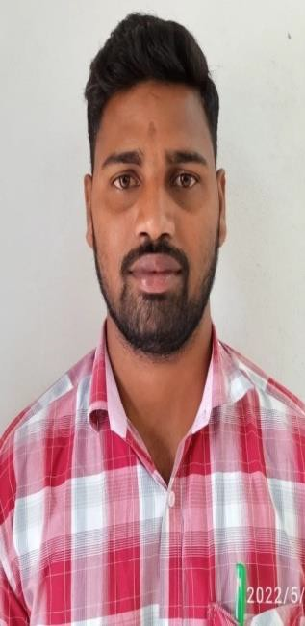
2 | Present Position: |  |  | Lecturer in Political Science  Since 30 November 2022
3 | Date of Birth and Age: |  |  | 12-02-1996 ,30 years
4 | Caste and Nationality: |  |  | BC-A, Indian
5 | Office Address:  Residence: | Office: |  | Department of Political Science SVSSC Government Degree College(A) Sullurpet, Tirupati District, Andhra Pradesh.  R.D.R Colony, in Allure, SPSR Nellor District, A.P.524315  pkraju012@gmail.com, Cell: 8466963845
6 | Educational Qualifications:
 | Name of the |  | Name of the | Name of the | Year | Class |  | Specialization
 | Class/ Degree |  | Institution | Board/University
 | (1) |  | (2) | (3) | (4) | (5) |  | (6)
 | SSC |  | Dr. L. K. R. V. B. H. SCHOOL Kavali, S.P.S.R. Nellore | Board of Secondary Education, AP | 2014 | Second |  | General
 |  |  | Dist.
 | Intermediate |  | Rama Krishna Junior College Allure, Nellore Dist. | Board of Intermediate Education, AP | 2017 | Second |  | Commerce, Economics, civics.
 | B.A |  | Rama Krishna Degree | Vikrama Simha Puri University | 2020 | Second |  | (EPC)  Economics,  Political Science,  Computer Science
 |  |  | College, Allure, |  |  |  |  | (EPC)  Economics,  Political Science,  Computer Science
 |  |  | Nellore Dist. |  |  |  |  | (EPC)  Economics,  Political Science,  Computer Science
 | M.A |  | P.G. Vikrama Simha Puri University, kakutur, Nellore Dist. | Vikrama Simha Puri University | 2022 | First |  | Political Science

7 | Project Work:
 | M.A | P.G. Vikrama Simha Puri University, kakutur, Nellore Dist. | Vikrama Simha Puri University | 2022 | First | “ Role of Regional Rural in A.P, A Study of Nellore DT “

The particulars above mentioned are true and correct to the best of my knowledge and belief.
Sullurpet,
09-04-2026 (Pralayakaveri Raju)

